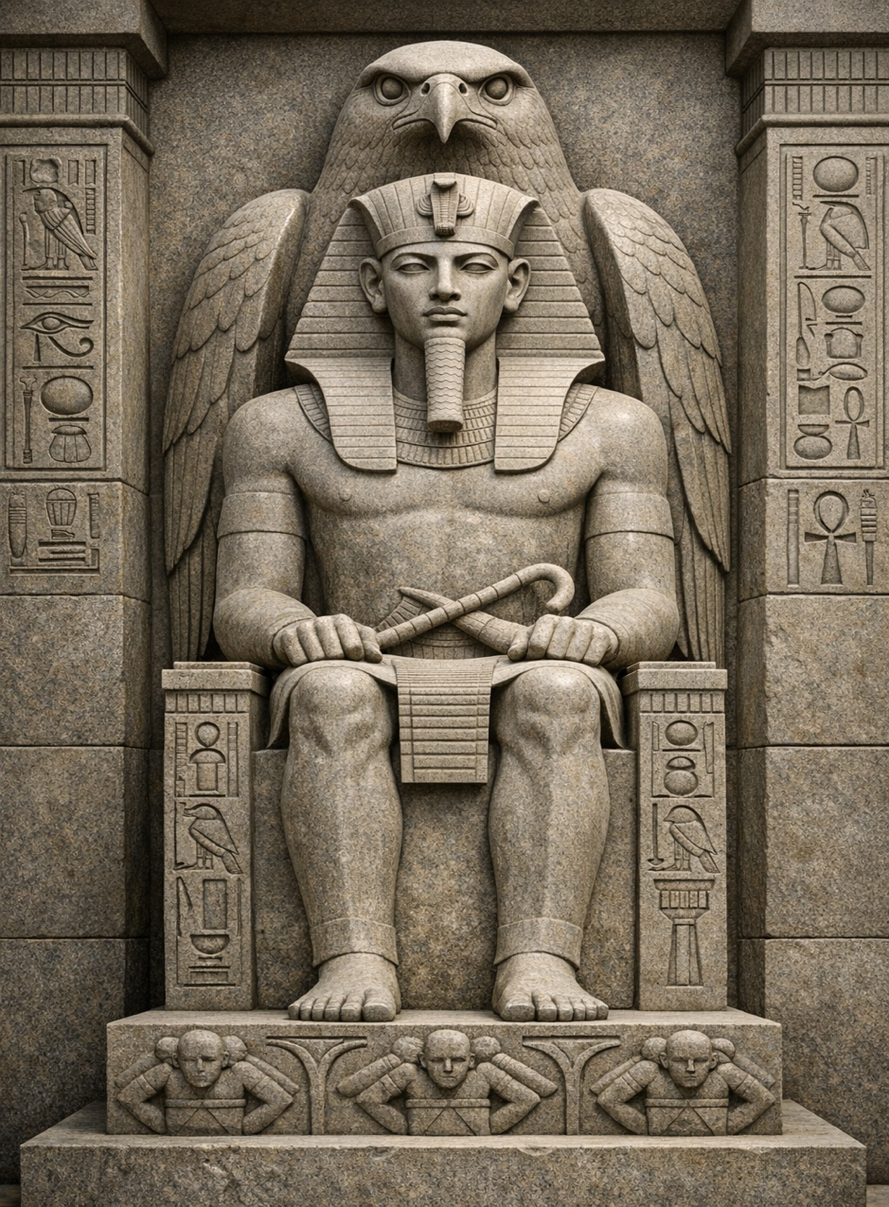
VISUAL PROMPT 1: IMAGE [ANCIENT EGYPT] LABLED AND EXPLAINED

Theme: Art as Divine Power
Historical Period: Ancient Egypt
Artwork Inspiration: Khafre with the Falcon God Horus

Explanation:
This image reflects how Ancient Egyptian art was used to show the divine power of rulers. The pharaoh is shown in a rigid, idealized form to communicate perfection and authority. The falcon represents the god Horus, symbolizing protection, and a direct connection between the ruler and the divine. The lack of emotion and strong symmetry emphasize timelessness and stability, reinforcing the belief that the pharaoh was not just a political leader but also a god-like figure. The purpose of this artwork is to demonstrate religious belief, political power, and divine authority.
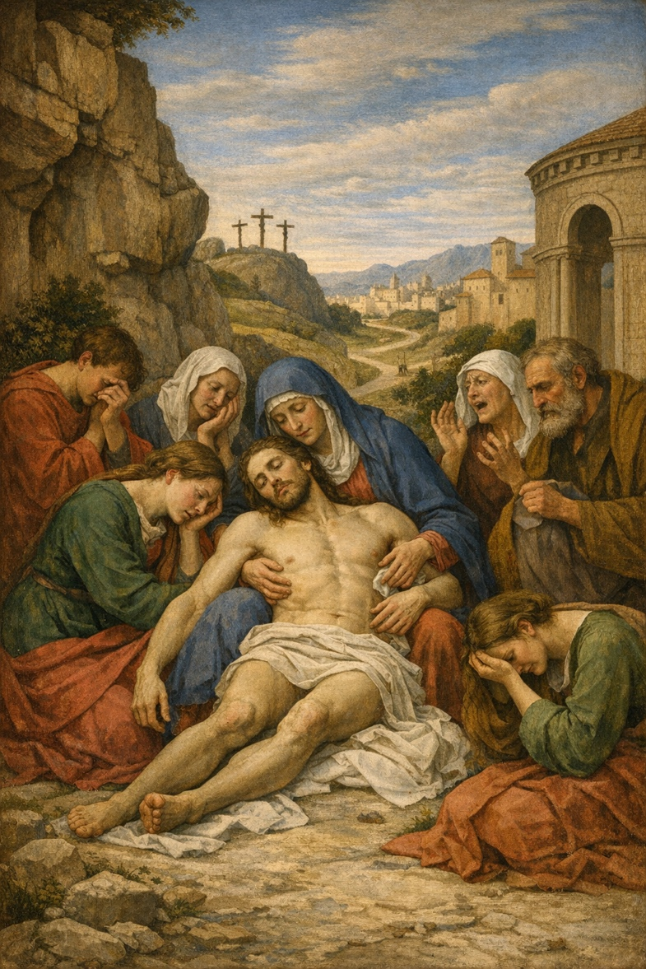

VISUAL PROMPT 2: IMAGE RENAISSANCE LABLED AND EXPLAINED

Theme: Humanism and the Move Toward Science
Historical Period: Early Renaissance
Artwork Inspiration: Giotto, Lamentation

Explanation:
This image reflects the shift during the Early Renaissance toward humanism and scientific observation. The figures are shown with realistic proportions, natural movement, and emotional expressions, emphasizing human experience rather than purely divine representation. The use of perspective creates depth and space, showing a growing understanding of mathematics and observation. The composition focuses on emotion and realism, demonstrating how artists began to study the natural world and human behavior more closely. The purpose of this artwork is to highlight the importance of human-centered thinking, realism, and scientific approach during the Renaissance.

